Referral for Surgery for the Treatment of Tongue-tie
Please send referrals to morrishouse.minorsurgery@nhs.net
Name:
NHS Number:
Date of Birth:
Baby’s Registered Address in Haringey:
Telephone Number (guardian):
Email Address (guardian):
Referring Clinician:
Practice/Clinic Address:
Practice/Clinic Telephone Number:
Practice/Clinic Email:

Patient consent must be confirmed for all referrals
GURDIAN Consent: | Mark or tick to confirm below
Applicable to Section 1
I confirm the guardian of the patient has consented to share the personal and clinical information contained within this proforma with clinical staff involved in their care, and for future audit purposes.

Referral Information:
Please provide full clinical detail in support of criteria selected: (Please enter text below.)

Tongue-tie surgery will not be funded to prevent feeding problems in the absence of documented feeding difficulty.
Referral criteria – Tongue-tie surgery will be funded in cases of a diagnosed tongue-tie from a recognised assessment where the following criteria are met: |  | Tick all boxes
Infant aged 0 to 12 weeks.

State age (in weeks):
And | Experiencing breastfeeding problems resulting in sore nipples, mastitis, poor infant weight gain or dehydration because of tongue-tie.  OR  Bottle feeding problems due to tongue-tie resulting in poor weight gain and dehydration.
And | Babies must have had either vitamin K injection or the second dose of oral drops more than 24 hours prior to the procedure.
And | Mothers have undergone a full breastfeeding assessment and counselling before the procedure to confirm that the tongue-tie is the cause of the issues with breastfeeding.
And | I confirm that I have provided the family with the attached leaflet.
And | I confirm that the parents do not have a known clotting disorder or family history of clotting disorder.
And | I confirm that the child is a resident of Haringey and/or registered with a Haringey GP.

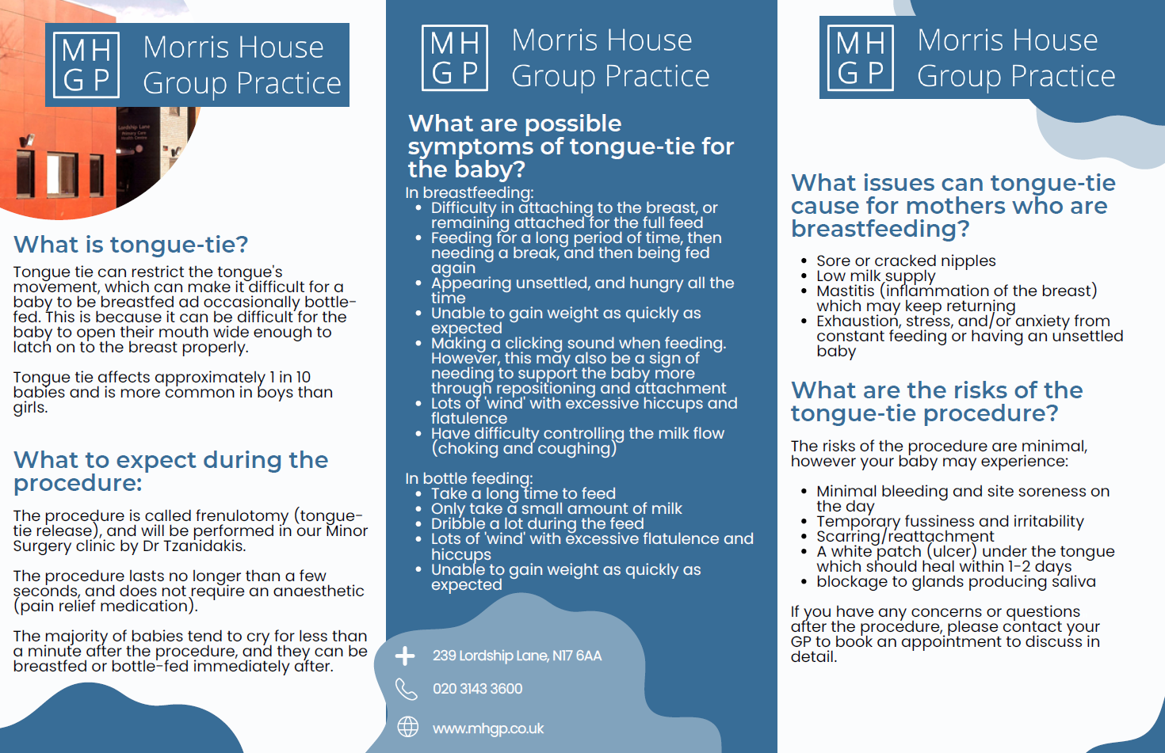
Tongue-Tie Information Leaflet:

